Lifecycle document – EEG

Working with EEG DATA: Introduction
Electroencephalogram (EEG) studies the electrical activity of the brain produced by large segments of neurons firing in tandem. EEG is particularly well-suited to studies that examine functional or effective connectivity and research where temporal resolution is important (da Silva, 2013).
Fluctuations in the voltage of ionic currents produced by neurons are recorded through electrodes (St. Louis & Frey, 2016). Electrodes are the physical sensors or transducers that are placed on the scalp to perform the analogue recording. They are connected to amplifiers, which not only amplify, but also filter the EEG activity. EEG data is represented by channels for each electrode, with voltages represented on the x-axis, and time represented on the y-axis. Event codes (which signal at what point periods of interest in an experiment occur) may be found at the bottom of the data graph along the y-axis (Acheson, 2019).
Although EEG has a far higher temporally resolution than fMRI, what it gains in temporal recording, it loses in spatial accuracy. This is because in order to be read on the scalp, the electrical activity must first travel through ‘biological filters’, i.e. the meninges, the skull and skin. This results in spread and reduced amplification (St. Louis & Frey, 2016). Some research has combined EEG and fMRI to great effect, but detailed elaboration on data management for studies combining the two modalities is beyond the scope of this primer. Instead we direct you to the Human Time Data fMRI data handbook for guidance on the management of this type of data. This particular guide will instead focus on data collection and management issues specific to EEG and aims to be particularly useful to the new beginner. For an in-depth overview of how to create a data management plan for your study, please see the Human Time Data guide Data Management: DMPs and Best Practices.
EEG Terminology
Channels are the digital signals recorded by the amplifiers. It is important to distinguish them from the sensors. Channels consist of two electrodes whose activity is referenced to another more distant electrode to form the signal (referential montages).
Signals are voltages at a given site at a given timepoint. The signal consists of different frequencies that can be derived/calculated via a time-frequency analysis. Delta waves range from 1-3 cycles per second (Hz), theta are 4-7 Hz, alpha are 8-12 Hz, and beta waves include those 13 Hz and higher. These can reveal the state that the participant is in, for example, wakefulness or sleep (St. Louis & Frey, 2016).
A session is a grouping of neuroimaging and behavioral data consistent across participants. A session includes the time involved in completing all experimental tasks. This begins when a participant enters the research environment and continues until they leave it. One session would typically start with informed consent procedures followed by participant preparation (i.e., electrodes placement procedure) and ends when the electrodes are removed but can also include a number of pre- or post- EGG observations and measurements (e.g., additional behavioral or clinical testing, questionnaires, structural MRI). Defining multiple sessions is appropriate when several identical or similar data acquisitions are planned and performed on all (or most) participants, often in the case of some intervention between sessions or for longitudinal studies.
A run is an uninterrupted period of continuous data acquisition without operator involvement.
An event is an isolated occurrence of a stimulus being presented, or a response being made. It is essential to have exact timing information in addition to the identity of the events, synchronized to the EEG signals. For this, a digital trigger channel with specific marker values and timing information is used.
The term epoch designates the outcome of a data segmentation process. Typically, epochs in event-related designs (for analysis of event related potentials - ERPs) are time locked to a particular event (such as a stimulus or a response). Epochs can also include an entire trial, made up of multiple events, if the data analysis plan calls for it.
A trial is a period of time that includes a sequence of one or more events with a prescribed order and timing, which is the basic, repeating element of an experiment. For example, a trial may consist of a cue followed after some time by a stimulus, followed by a response, followed by feedback. Trials of the same type belong to the same condition. Critical events within trials are usually represented as “triggers” stored in the EEG data file, or documented in a marker file.
Source space refers to EEG expressed at the level of estimated neural sources that gave rise to the measured signals. Each signal maps onto a spatial location that is readily interpretable in relation to individual or template-based brain anatomy.
Anatomical landmarks are well-known, easily identifiable physical locations on the head (e.g., nasion at the bridge of the nose; inion at the bony protrusion on the midline occipital scalp) that have been acknowledged to be of practical use in the field.
Acquisition parameters are the reported reference and ground electrodes used in data acquisition. Similarly, reference electrode(s) used in data analysis are also reported. Additional electrodes are sometimes applied to the face to measure eye movement, and their exact spatial positions are specified, preferably with reference to well-known anatomical landmarks (e.g., outer canthus of the eye).
Electrode Placement
As per the convention of the international 10-20 system, each electrode is named by either a letter and a number, or two letters. The first letter represents the area of its placement in relation to the brain: F = frontal lobe, T = temporal lobe, P = parietal lobe and O = occipital lobe. Odd numbers relate to the left side of the head, while even numbers indicate the placement on the right side. Electrodes placed down the center of the head are not numbered but are instead paired with a ‘z’ for zero. Other sites including the ears and mastoid region begin with an ‘a’ followed by a number indicating which side of the head it was placed using the odd and even number schema (St. Louis & Frey, 2016). Derived channels can help indicate where eye blinks and vertical eye movement occurs. Some researchers use two electrodes assigned to blinks, and two which record vertical eye movement (Acheson, 2019), while others may use one electrode for each type of eye movement.
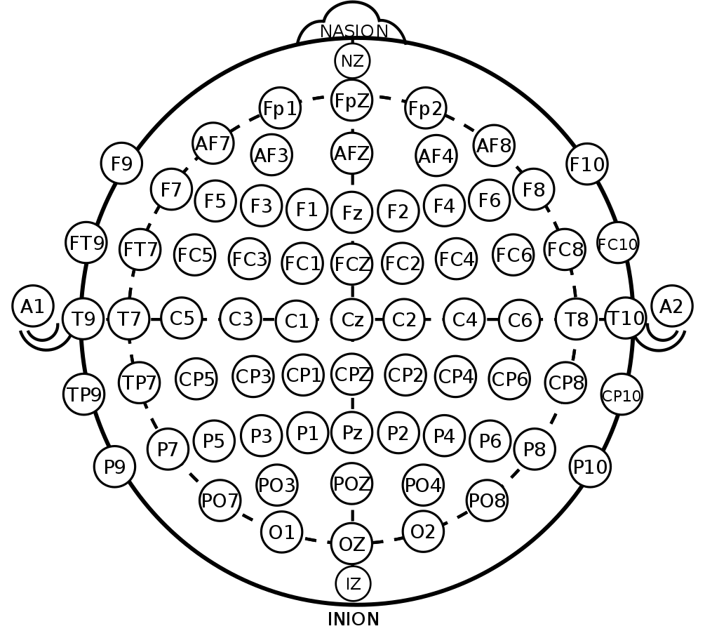
EEG-experiment Start-up
An EEG study typically follows several specific steps. First one sets up the experiment itself, using various software, then pre- and pilot testing may be followed by the actual data acquisition and finishing with the analysis.

Experiment Setup
While setting up an experiment one must decide which software to use for stimulus presentation. At UiO, researchers have the choice between several options: E-prime, Matlab/Psychtoolbox and Python/PsychoPy. The following table gives a short overview of the programs.
 | E-prime | MATLAB/Psychtoolbox | Python/ PsychoPy
GUI/ Script | Yes/ limited | No/ Yes | Yes/ Yes
Price | Free at UiO; otherwise ~$1000 | MATLAB free at UiO; otherwise $50-500; | Free/ open source
Ease of use | Easy | Moderate | Moderate
Flexibility | Moderate | High | High
Timing control | Moderate | High | High
Connection to EEG system | Can be hard; own scripting required | Easy; several functions available | Easy; several functions available

Pre-tests

Pre-tests are preliminary testing of sequences, equipment and stimuli scripts performed in the EEG lab before data collection begins.

Pilot tests
Before collecting data for the experiment, it is necessary to discuss the experiment design with colleagues and have them perform the task to give feedback on its design. Pilot test your experiment behaviorally to make sure you can obtain the predicted behavioral effect before proceeding to collect brain data.
After testing the experiment behaviorally, EEG data from 2-5 subjects are usually collected and analyzed, including the analysis corresponding to the main hypotheses. After the analysis of these datasets, flaws, suboptimal design features, extraneous conditions or the need for additional conditions may be found.
TIPS! Pilot datasets can be used for the final analyses if the following criteria are met:
- The procedure/design is satisfactory.
- The experiment will not be changed after the pilot.
- The pilot participants fulfill the study's inclusion criteria.

Data Acquisition

Equipment

The Psychology Department at the UiO uses EEG systems from two different suppliers in its labs; BIOSEMI’s and Brain Products. While all EEG systems are fundamentally the same, there are distinct differences between these systems.
BIOSEMI: The ActiveTwo System:
The ActiveTwo system is capable of data acquisition from up to 256 active electrodes. At the Psychology Department, the 64-electrode version (which utilizes the standard 10-20 electrode grid scheme) is typically used. Additional flat-type electrodes with individual leads/connectors are available and can be placed anywhere according to the researcher’s requirements. The ActiveTwo system is unique in comparison to most systems in that it natively records data without reference, but with a common mode sense (CMS) and a driven right leg (DRL)electrode, requiring it to be re-referenced offline during later processing (for more information see: https://www.biosemi.com/faq/cms&drl.htm).
The system is also capable of receiving external event code triggers through a single 16 bit interface (two 8-bit parallel ports) using an external integration box (part of the ActiveTwo system) which interfaces directly with the acquisition hardware prior to reception with the PC.
Biosemi ActiveTwo EEG data acquisition setup.
Major components of a typical EEG recording system.
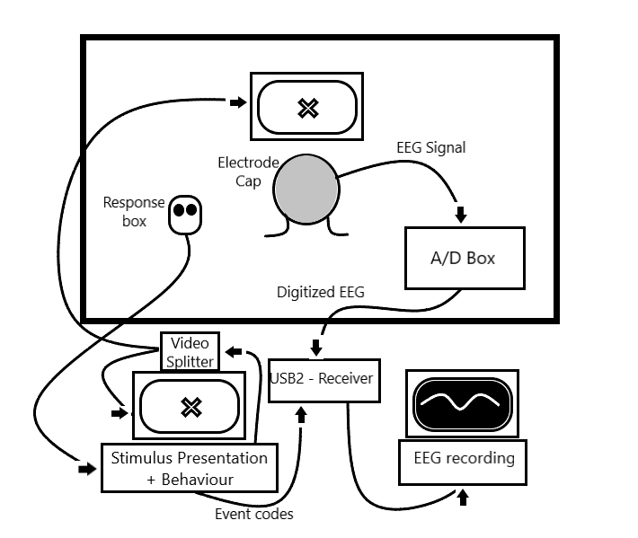

The flat-type active electrodes are designed specifically for use on bare skin for measuring EOG, ECG, EMG or EEG at mastoids, earlobes, nose, nape of the neck, e.g. EOG (electrooculogram) signals. These are combined with EEG signals in order to improve artifact detection (i.e. eye movements and blinks) and trial rejection.
Consequently, EOG is monitored along with EEG to improve one’s ability to distinguish between artifacts and real data. This is sometimes necessitated by a population of interest that is unable to control their eye movements or by the experimental paradigm itself. In experiments where visual fixation is required, EOG is often used simply to exclude trials on which a participant moved their eyes. Below is a diagram of a generic ActiveTwo EEG data acquisition setup.
Brain Products:
In contrast to the ActiveTwo system, most Brain Product systems used at the department use passive electrodes. While the systems are able to collect data from up to 64 electrodes, the number of electrodes used can be easily changed and adapted to the study. As with the ActiveTwo system, additional EMG/EOG/etc. electrodes can be used to suit the study’s needs.
One must specify reference and ground electrodes used during the study. The positions of those two electrodes can vary widely according to the needs of the study, the opinion of the researcher, etc. When unsure of where to place them, ask the PI or another experienced EEG researcher for advice. All electrodes must be specified in a workspace, which tells the recording software from which channels to record and assigns standardized positions to the electrodes. The workspace also specifies different parameters like, for example, sample rate.
Usually two computers are used in EEG recording. One computer presents the stimuli and monitor behavior, while the second records the EEG. These functions are not ordinarily combined into a single computer, because each requires precise timing, and it is difficult to coordinate multiple real-time streams of events on a single computer. For later analysis, stimulus presentation and responses must be recorded along with the EEG signal. For this purpose, both the A/D box and the stimulus computer are connected to a trigger box (in Biosemi USB2-Receiver) where event codes from the stimulus computer are integrated with the EEG signal. These event codes are later used to extract time-locked epochs from the EEG data.

Raw data types and structure
ActiveTwo / ActiView file format. ActiView data files are stored in a format known as BDF, which is an open, documented file format patterned after the European Data Format (EDF). Both are supported by many signal analysis software tools. In fact, the only substantive difference between BDF and EDF files is the fact that the EDF data files have 16 bits per data sample, while the BDF data files have 24 bits per data sample. The BDF file format is supported by a wide variety of signal analysis software tools, including EMSE Suite, BESA, g.BSanalyse, EEGLAB, BIOSIG .
The 24-bit file format has the practical consequence that files are slightly smaller than they would have been when stored with 32-bits. However, reading and converting the 24 bit numerical representation is slow because 24-bit is not a standard numerical representation on Intel computers. MATLAB allows for reading single bits or 8-bit values from a file, which can be used to construct the 24-bit value, but this process is also very slow. To speed up the reading, FieldTrip uses a .mex file that reads the 24-bit values and converts them to a 32-bit representation.

EEG data acquisition systems and their outputs.

BrainProducts file format. Brain Products uses the BrainVision Core Data Format. It is recognized by the BIDS framework as one of the official EEG/iEEG data formats and consists of three different files (i.e. every EEG recording will yield three
different files). These include a header file (*.vhdr) containing the different recording parameters and additional meta-information in text format, a marker file (*.vmrk) containing the events recorded during the session in text format, and a binary raw EEG data file (*.eeg) containing the recorded EEG data, plus additional signals. All files will have the same base name (given at the start of recording).
File | Extension | Type | Content
Brain Products header file | *.vhdr | Text | Recording parameter; meta-data
Brain Products marker file | *.vmrk | Text | Information about events in the data
Brain Products data file | *.eeg | Binary | Voltage values of EEG
Biosemi BDF | *.bdf | Multiple | Multiple; see https://www.biosemi.com/ faq/file_format.htm for full explanation

The high sampling rate of EEG data (typically 1-5 kHz, i.e. 1000-5000 Hz) has the consequence that files are much larger than with most acquisition systems. That means that for processing EEG files, you typically will need a computer with more than the standard amount of RAM. After reading the data in MATLAB memory, a common procedure is to down sample it to reduce the sampling rate to 500 Hz (using the ft_resampledata function in FieldTrip). This will make all subsequent analyses run much faster and will facilitate doing the analysis with less RAM. However, it is important to filter the data using a low-pass filter of at least half the desired sample rate (e.g. 250Hz) or lower to avoid aliasing (see Nyquist theorem for more information). EEGLAB in MATLAB and MNE-python do this step by default when you use the respective toolbox resample function, however, FieldTrip does not.
MRI Data
Structural magnetic resonance imaging (MRI) scans are often made of participants to aid localization. Should a researcher not have access to a scanner, scaled templates can be used for localization, however, structural scans are preferable. A cortical mesh can be constructed by using the normalized structural scan and co-registering the EEG data according to the fiducials (Henson et al., 2019). As stated previously, some studies may also combine both EEG and fMRI. Thus, it is important to also have some basic understanding about these forms of data as well. For a more thorough introduction to (f)MRI data, please see our guide on the topic.
The raw data which is taken directly from the scanner is typically extracted as DICOM files. DICOMS entail a very high volume of data. Thus, one should ensure that the password-protected, encrypted hard drive used for transferring files from the scanner to Lagringshotell is large enough to account for this. DICOMS must be converted to NIfTI files, which is the format used by most modern neuroimaging analysis software. DICOMS may need to be sorted and re-named prior to conversion to NIfTI. Some conversion applications will automatically create a single NIfTI file from the DICOM images (.nii), while others may offer a two file option with an image file (.img) and a header (.hdr). Alternately, JSON files can be created by some programs to supply metadata that may be lost in DICOM conversion. These .json and .nii or nii.gz (the compressed version of NIfTI) are required by the BIDS protocol.

File | Extension | Type | Content
DICOM raw data | .dcm  sometimes no extension | image | Structural or functional MRI data. DICOM files have an embedded header file.
NIfTI | .nii  .nii.gz (compressed)  .img & .hdr | image | Structural or functional MRI data file used by most analysis software. Can be produced as one file (.nii) or as two files with both the image (.img) and a header (.hdr). Files produced in pre-processing and analysis may also be NIfTI format.
JSON | *.json | metadata | Often created along with a .nii to capture metadata that otherwise may be lost in conversion from DICOM to NIfTI.

Data Analysis
Data analysis often occurs locally on a researcher’s office computer by accessing files stored in Lagringshotell. Recently, VDI’s have become a popular tool for preprocessing and data analysis.
VDI – Virtual Desktop Infrastructure. A VDI offers users access to a virtual computer with the software and processing power they need. This computer can be used in the same way you use your local computer but can be reached from different devices and operating systems. Which programs that are mounted and can run on the VDI machine is decided together by yourself, your local IT and program managers at the departments. A VDI may offer advantages over using one’s office desktop computer for analysis, as the VDI processing capabilities are more powerful. The lab engineer can be contacted for more information about how to connect and use UiO's VDI's.

Software – Data structure and data types
Many of the available EEG systems come with analysis software packages with varying levels of detailed descriptions of how the different preprocessing tools are implemented. In addition, several free and commercially available software packages that run on MATLAB/Python/R platforms, offer alternative implementations of data analysis tools. At the psychology department at UiO, MATLAB is the dominant software used for EEG data preprocessing, analysis, and visualization. MATLAB is a high-level programming environment that is relatively easy to learn and use. Several of the most ­­widely used EEG analysis packages are MATLAB toolboxes (e.g. EEGLAB; FieldTrip). MATLAB has a development environment that makes it easy to access large amounts of data. This is advantageous because one can easily inspect data during each stage of processing and analysis. One can also easily inspect and compare results from different subjects. MATLAB is also able to compute plots of your data that are customizable. These can be exported as pixel-based image files (.jpg, .bmp, .png, .tiff), vector files (.eps), or movies, which can be used to make presentations and publication-quality figures. In addition, custom-written software for preprocessing and subsequent analysis is commonly used. In-house software is usually notated by the researcher with descriptions and comments on the script.
Tips: In most cases, when you have EEG data in several different file formats, loading the data into the analysis software converts the files so they conform to the standard format that is native for the program. However, in some cases you may have to convert these files manually.

Preprocessing and Analysis Considerations
EEG data has a low signal to noise ratio. Artifacts can occur due to participant movement, blinking, cardiac function, scalp muscles, swallowing or even the temporary dislocation of electrodes. Filters to remove artifacts should be used with caution as they may also distort the activity of interest (St. Louis & Frey, 2016). Using the data from the derivative channels for eye blinks and vertical eye moment, one can perform independent components analysis (ICA) to clean these artifacts from the data (Acheson, 2019).
The primary derivatives of EEG are evoked potentials and event-related potentials. Evoked potentials (EP) is a electrical potential in following a stimulus recorded/seen in spontaneous EEG and is NOT time-locked to the event. In the case of EP, one averages the electrical activity within a specific period in which a stimulus was presented. Time-locked/event-related potentials (ERP) are measured brain responses that are a direct result of stimulus presentation and are time-locked to the event.

The next step in preparing EEG data for analysis is to filter it to remove low and high signal frequencies. Using a bandpass filter, one can achieve a more smooth, defined signal. The data must then be segmented into epochs that correspond to the onsets of events of interest in the experiment. This is done using the event codes from the data file (Acheson, 2019). Epochs can also include an entire trial, made up of multiple events, if the data analysis strategy calls for it.
Next, these epochs are put on the same scale by averaging the signal from a short time prior to the onset, or the ‘baseline period’ and subtracting the average from every time-point in the epoch. You will also want to remove any epochs or signals that carry values too extreme, which are likely due to artifacts or a dysfunctional electrode. These will otherwise distort the effect (Acheson, 2019).
The exact details of analysis will vary by study, but typically the next steps in analysis entail averaging signals in the events of interest within subjects, followed by averaging these averages across subjects (ibid).
Tips! In most cases, when you have EEG data in several different file formats, loading the data into the analysis software converts the files so they conform to the standard format that is native for the program. However, in some cases you may have to convert these files manually.

Behavioral Data
Additional behavioral data can be acquired from the stimulus presentation software. This data can be used in conjunction with the EEG data during analysis. Their use tends to vary according to the study’s needs. For example, you may require information about a participant's responses or response times in order to understand the patterns of activation in your EEG data. Presentation, Psychtoolbox for MATLAB and E-Prime tend to be the most popular programs for experiments in labs, however open source programs like PsychoPy are coming more and more into use. Paradigm, PEBL, and Inquisit are additional programs for creating neuroscience experiments that you may encounter.

Data sharing

When sharing (or intending to share) data, scientists should keep certain things in mind to make the lives of their colleagues easier, as well as to protect privacy of the participants.

Metadata

The brain imaging data structure (BIDS) (Pernet et al., 2018) is a format to share neuroimaging data using agreed upon standards created by the neuroimaging community. BIDS offers a systematic way to organize data into folders using dedicated names, in association with text files, either as tabulated separated value file (.tsv) or JavaScript Object Notation file (.json) to store metadata. We encourage the EEG community to share their data by using this data structure as it facilitates communications, increases reproducibility and makes easier to develop data analysis pipelines. See our handbook Structuring Data with BIDS for more information.

Research data archiving.
There are both national, international, and domain-specific archives that meet international standards for archiving research data and making it accessible. UiO’s researchers can choose the archiving solutions that are most appropriate to their discipline and that meet the conditions of applicable legal frameworks. Depositing data resources within a trusted digital archive can ensure that they are curated and handled according to best practices in digital preservation.▪

- Re3data.org (a global list of archives)
- ▪Zenodo (EU’s archive)
- ▪NSD (national archives)
- ▪NIRD/Sigma 2 (national archives)
- ▪DataverseNO (national archives)
See our guide on data management for more information.

Anonymization
EEG data itself (as well as the related behavioral data) do not constitute sensitive data, however, it is important to anonymize data from the start of data collection by providing participants with participant numbers and keeping any identifying information like name, address, phone number, birthday or national identification number separate from the EEG data. Name, contact information and the subject’s ID are not stored together. Documents where ID and name are linked are stored on encrypted storage mediums. Those devices should be stored in locked cabinets separate from the data. These steps are of even greater importance when one is working with patient populations.
MRI or fMRI data used in conjunction with EEG data is another story. Neuroimaging data is inherently sensitive and requires safe handling of data. Data is removed from the scanner on password-protected, encrypted hard drives. At the point of transfer of data from the scanner to external encrypted hard drive, one must always remember to check the box for anonymization of the data at the scanner console and designate a participant number or alias instead. This is because DICOMs have headers that contain identifying patient data. If anonymization is not performed at the source, the DICOM headers must be anonymized by hand, which can be time-consuming. Storage of neuroimaging data is permitted only in TSD or Lagringshotellet at UiO. Some patient groups may only be stored in TSD. Prior to data archival and sharing, neuroimaging data must be defaced. This can impede locating the nasion, so this is often only done in the context of data sharing.
Creating a Data Management Plan for EEG Research
Now that you are familiar with some of the data-related topics and concerns that should be considered when conducting an EEG study, you may feel better equipped to complete a data management plan document. The following offers questions specific to EEG data to guide the creation of such a document. For a more in-depth exploration of how to create a data management plan, please see the HTD guide Data Management. DMPs & Best Practices.
Who is the study’s P.I.? What other team members will be involved in data collection and analysis?
What software will you use for stimuli/experiment presentation and behavioral data collection?
What software do you foresee using for analysis?
Knowing what software will be used ahead of data collection will help you to make an appropriate data management plan from the start.
How will your data be handled in the curation phase, once the study is over? What data repository will you use? What requirements do they have for data management? Can you maintain this standard throughout the study? What will data curation cost?
Many data repositories have requirements for file structure and naming conventions, as well as the file types that are preferred. If you are aware of these requirements beforehand, you can save time once the time for curation arrives by using those guidelines over the course of the study. You will need to know and plan for the costs that will be incurred for data sharing and curation when applying for funding.
Who is funding the study? What are the funder’s requirements for data management plans?
Most funding entities require at least a basic data management and data sharing plan to accompany funding applications.
What information will be provided to participants in advance of participation and in what form? What are your plans for collecting informed consent? How will you store the consent forms once they are collected?
How will you store the data key linking participants to their data?
If you will collect sensitive data, how will it be stored and analyzed? What protections will be put in place to ensure anonymity is maintained?
At UiO, sensitive data can be stored and analyzed in TSD or on Lagringshotellet, depending on the degree of sensitivity of the data.
How will you store non-sensitive data? In what environment do you plan to analyze it?
Who will have access to the data? Who is responsible for transferring data to storage once it is collected?
What file naming conventions will be used for the various file types that make up your dataset?
Will you use in-house written code? What programming language will you use? Will this code be made available to the scientific community? If so, where will it be made available?
Will you maintain a lab notebook? How will the lab notebook be used and who will have access?
Digital lab notebooks are now quite common, but can raise questions of data security.
Will you convert proprietary file types to more standardized file types prior to sharing your data?
How will the findings be disseminated?
How will you record metadata related to the study for future sharing?
Metadata is data about your data that can help researchers who later want to access your data to understand how the study was conducted. It may also help members of your current team understand the data they are working with.
Who will be responsible for the data in the long term once the study is completed?
This is important to consider for all studies, but especially important for longitudinal studies. Personnel and staff may leave your institution or be difficult to contact in the future. A primary contact person who is responsible for the data should be designated. Should they leave the institution or retire and a new responsible party is designated, then the repository should be updated with their information.

References
Recommended Resources
Acheson, D [Cognitive Neuroscience Compendium]. (22.04.2019). Introduction to Event-Related Potentials. [Video file]. Retrieved from https://www.youtube.com/watch?v=zDTsePeDlwo.
Ceonic, J. (2020). A brief introduction to EEG and the types of electrodes. [Web]. Retrieved from https://www.brainlatam.com/blog/a-brief-introduction-to-eeg-and-the-types-of-electrodes-75.
Cohen, M.X. (2014). Analyzing Neural Time Series Data: Theory and Practice. Cambridge, MA: The MIT Press.
Da Silva, F.L. (2013). EEG and MEG: Relevance to Neuroscience. Neuron, 80(5) : 1112-1128.
Delorme, A., & Makeig, S. (2004). EEGLAB: an open source toolbox for analysis of single-trial EEG dynamics including independent component analysis. Journal of neuroscience methods, 134(1), 9-21.
Flandin, G., & Friston, K. J. J. S. (2008). Statistical parametric mapping (SPM). 3(4).
Gasser, T. & Molinari, L. (1996). The Analysis of the EEG. Stat Methods Med Res, 5(1): 69-99.
Gramfort, A. et al. (2014). MNE software for processing MEG and EEG data. 86, 446-460.
Henson, R.N. et al. (2019). Multimodal Integration of M/EEG and f/MRI Data in SPM12. Frontiers in Neuroscience, 13: 300.
Luck, S.J. (2014) An Introduction to the Event-Related Potential Technique. Second Edition. Cambridge, MA: Bradford Books.
Malik, A.S. & Amin, H.U. (2018). Designing EEG Experiments for Studying the Brain. Design Code and Example Datasets. Elsevier Academic Press. https://www.sciencedirect.com/book/9780128111406/designing-eeg-experiments-for-studying-the-brain.
Oostenveld, R. et al. (2010). FieldTrip: Open Source Software for Advanced Analysis of MEG, EEG, and Invasive Electrophysiological Data. First edition. Computational Intelligence and Neuroscience, Article ID 156869: 1-9. doi:10.1155/2011/156869
Pernet, C. et al. (2019). EEG-BIDS, an extension to the brain imaging data structure for electroencephalography. Scientific Data, 6, Article number: 103. https://www.nature.com/articles/s41597-019-0104-8
St. Louis, E.K. & Frey, L.C. (2016). Electroencephalography (EEG): An Introductory Text and Atlas of Normal and Abnormal Findings in Adults, Children, and Infants. American Epilepsy Society. Retrieved from https://www.ncbi.nlm.nih.gov/books/NBK390346/.

